Lab Report – Towers of Hanoi

Bugs:

1. Won the game but didn’t encode all the moves, nor does it update:

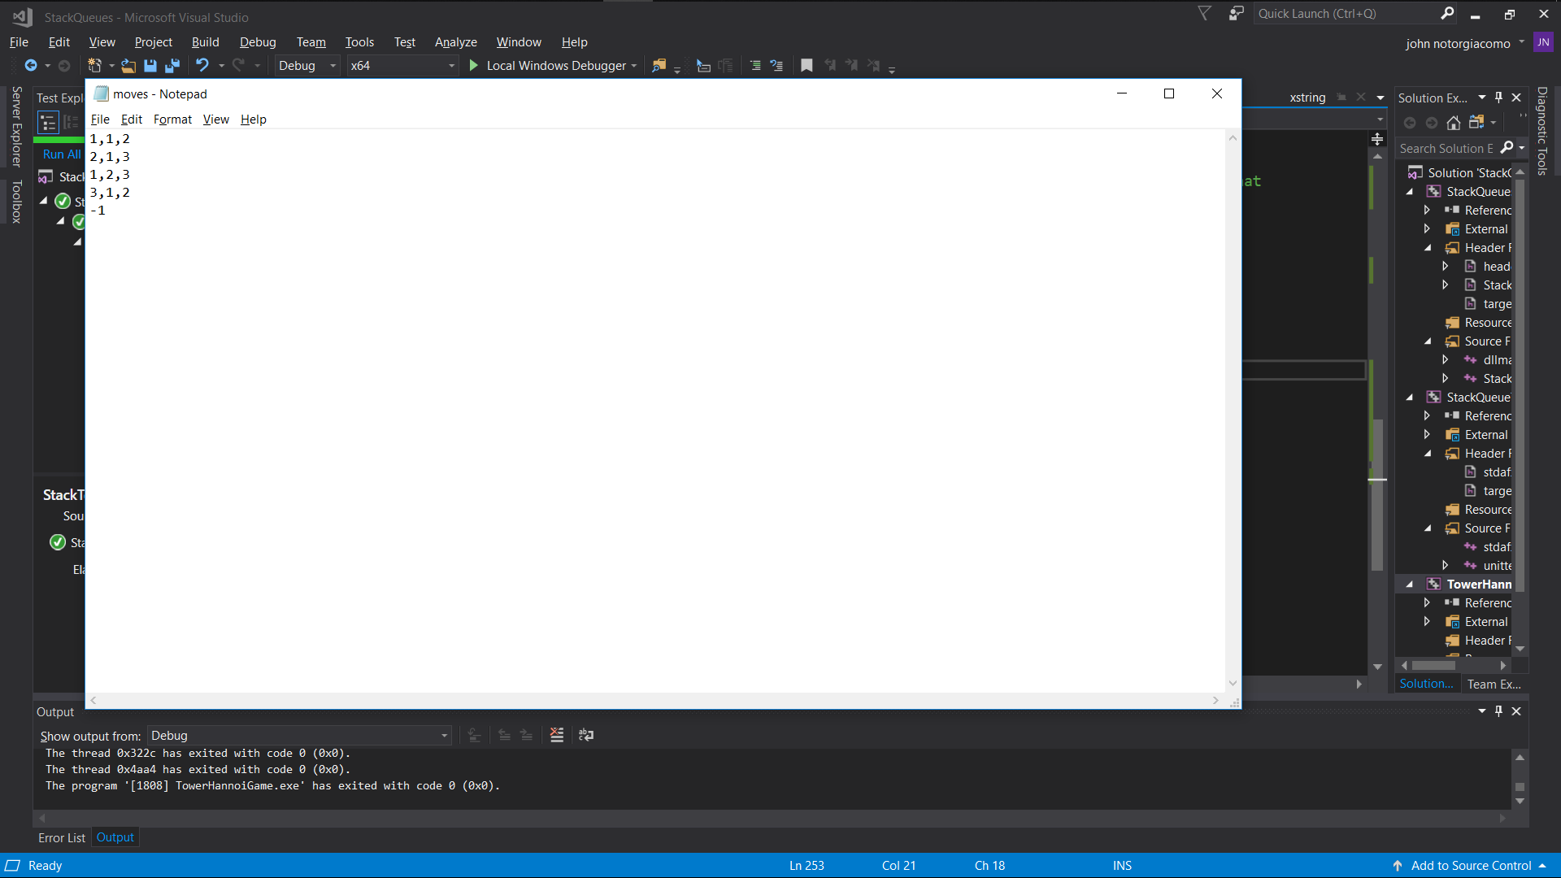

* 1. Solution: changed the file branch it was saved to and found it correct

1. Couldn’t end the game by winning or requesting to end

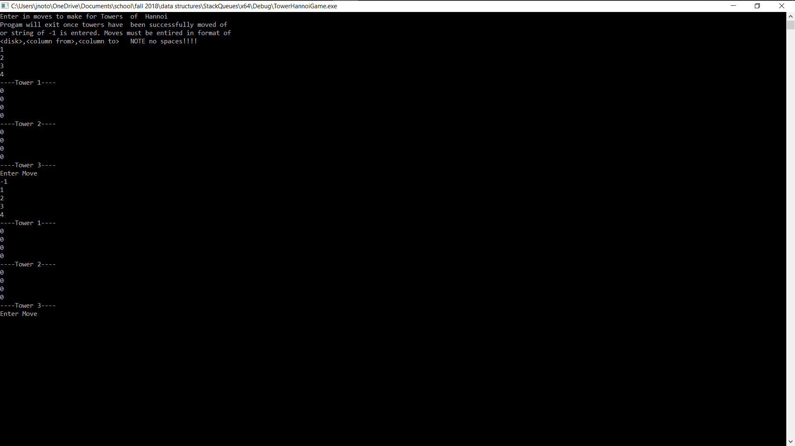

* 1. Solution: changed my while loop statement to and && instead of ||

1. Couldn’t push out the 0’s I had pushed into the other stacks, thinking to initialize them

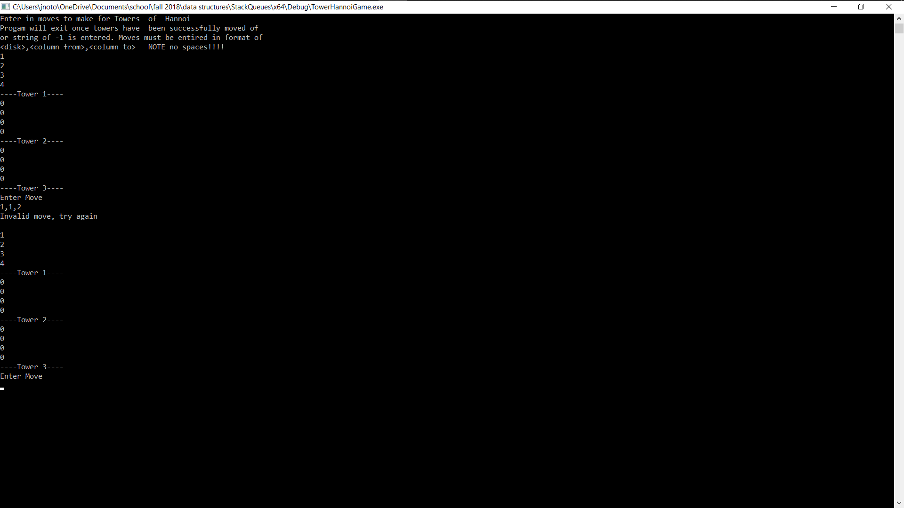

* 1. Solution: no longer push anything to empty stacks; was doing so because peeking at an empty stack caused errors. So, I changed the base value of every stack “peek” top to be 5, until changed intentionally (so that anything could be stacked on top of it and anything can be pushed into it, but the tower values all remained the same

Game won and played to completion:

